System Requirements:
Minimum:
- Windows XP or Windows 7
- 1.8 GHz Intel or AMD Processor,
- Graphics card with at least 128 MB memory
- 2.0 GB of RAM
- A sound card
- 150 MB free on your hard drive.
- Fully updated drivers
- Windows Vista is not recommended for use with Dr. Meatloaf

Recommended:
- 2.3 GHz Intel Dual-core Processor
- 100% DirectX® 9.0c compatible 16-bit sound card and latest drivers.
- 256MB Hardware Accelerated video card
- 4.0 GB RAM

How to Install Dr. Meatloaf:

- To install Dr. Meatloaf, insert the CD-ROM into your computer.
- A menu should appear automatically (if it does not, click on the start button in the lower left-hand corner of the screen, select My Computer, and click on the CD-ROM icon).
- Choose to view the files on the CD-ROM and doubleclick Dr. Meatloaf.exe. The game will install to the start menu, and can be played from the link provided

Purpose and Game Description:

Profiles:

Profiles are by far the most important part of the game. Your profile stores which levels you’ve beaten, your highest scores on each level, and most importantly, which cheats and unlockables you’ve accessed, such as extra multiplayer characters. Your profile can be accessed through the profile select menu, which is the first menu in both the 1 player and 2 player experiences.

(screenshot)

To select a profile in the Profile Select Menu, type the correct option into the console at the bottom of the screen. This will also provide the option to create a new profile, delete an old one, or return to the main menu. Your profile will be automatically saved after every level.

Single Player:

To play a single player game, hit the single player menu on the main menu. Then select your profile, or create a new one as detailed above. From here, select your difficulty, and then which level you’d like to play. At first, you can only play levels 1-4. These levels can be played in any order as many times as you want. Once you have beaten each level at least once on the same difficulty, Level 5 will unlock. Level 5 will then be playable on both single and multiplayer. At this point, an information screen will appear. Read over this as there will be a quiz at the end of the level. Click to move beyond and the game begins.

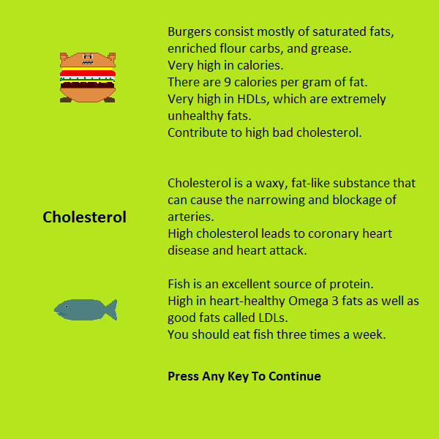

The objective is to use the arrow keys to move over and eat every good food while avoiding the bad foods, and above all else keeping your health above 0. The good foods provide a small bonus to player health, while enemies will hurt player health. Both amounts are dependent on difficulty. There is also a time limit in which the game must be completed. If there are still good foods remaining at the end of that time, the game is lost. Players have three chances to complete a level. After beating the level, players get the chance to answer a quiz question. If answered correctly, this will boost the player’s score.

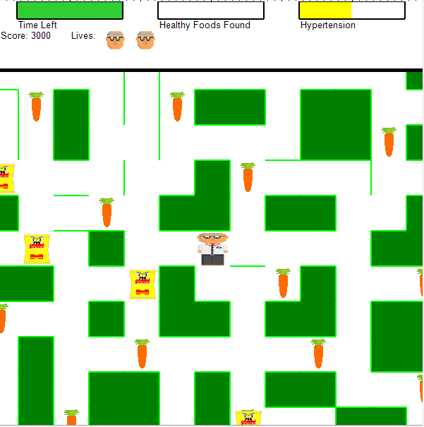

In level 5, Burger Bob, the ultimate boss appears. Hitting him will cause you to instantly lose, and he can pass through walls. Therefore, you must avoid him at all costs.

Multiplayer:

Multiplayer begins exactly like singleplayer, but after the info screen, there is a character selection screen

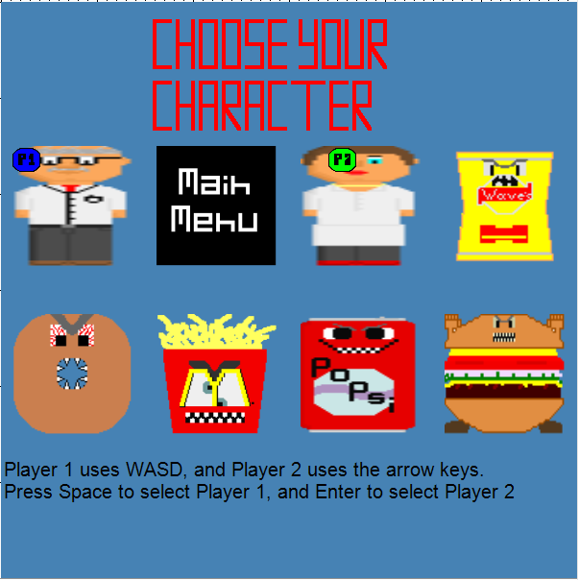

The character screen is entirely keyboard-based. Player 1 controls their selection via WASD and selects with space, while player 2 selects their character via the arrow keys and enter. At this point, the game begins.

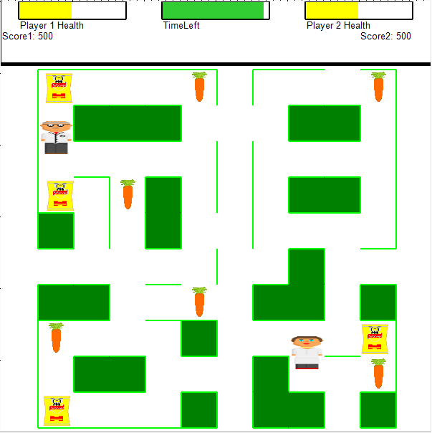
Player 1 is controlled by WASD and Player 2 is controlled by the arrow keys. The objective is to end the 30 second game period with as high a score as possible. A player’s score increases when they eat a good food and decreases when they eat a bad food. Also, the higher a player’s final health is, the higher their score. Enemies and good foods will disappear when a player runs into them, and automatically respawn in a random location a second later. The person with the highest score at the end of the game wins.

Scoring, unlockables, and high scores:

Single Player Scoring: Single player scoring is determined by how many enemies you hit(bad), your final health(good), how long it took you to complete the level(bad), how many tries it took you to defeat the level(bad), whether you got the question right(good), and the difficulty(good)

Multiplayer scoring is determined by the players final health, the number of enemies they’ve hit, and the number of good foods they’ve hit.

Unlockables come in 3 varieties: extra characters for multiplayer, a bonus difficulty, and cheat codes. The characters can be achieved by completing various achievements within the game. The bonus difficulty is achieved by beating all 20 previous levels, and the cheat codes are activated when all 25 levels are beaten.

Controls:

Movement-Singleplayer: Up, Down, Left, Right arrows

Movement-Player 1: Up, Down, Left, Right arrows

Movement-Player 2: up-W, down-S, left-A, right-D

Shortcuts:
M: mute/unmute
Q: quits game
P: pauses/unpauses game

Least you need to know:
- Installation: To install and play Dr. Meatloaf, double-click on the provided .exe file. The game will run setup and install to the start menu. Use the provided link to play Dr. Meatloaf.

- How to play single player

- Hit the Single Player button on the main menu
- Pick or create a profile: profiles store your overall progress through the game.
- Pick a difficulty from the difficulty selection menu.
- Pick a level from the level selection menu. Level 5 should be locked. Beat levels 1-4 for that difficulty to unlock it
- An info screen will appear, showing information about good and bad foods. There will be a quiz
- To beat the level, use the arrow keys to pick up all the good foods, while avoiding the various enemies.
- If you win, a question will appear. Answer correctly to boost your score.
- Continue beating more levels to earn various rewards and unlockables.

- How to play Multiplayer

- Hit the Multiplayer button on the main menu
- Pick or create a profile: profiles store your overall progress through the game.
- Pick a difficulty
- Pick a level from the level Select menu. Any levels unlocked on single player are unlocked on multiplayer
- An info screen will appear.
- Now, both players will select their players. Player 1 uses “WASD” to move and space to select their player, while player 2 uses the arrow keys and enter.
- Players then spend 30 seconds trying to achieve the best score possible. Enemies and Good foods will respawn periodically. All cheats are disabled.
- The player with the best score wins

